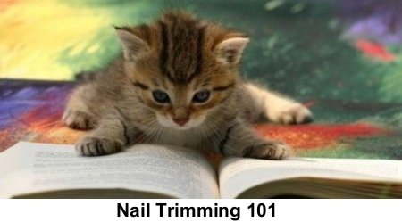
Provided by ASPCA
Make manicures enjoyable and easy for both you and your cat
Does your kitty disappear when the clippers come out? Do you have to wrap her in a towel to give her a manicure? According to our behavior experts, calm, enjoyable nail-trimming sessions are not only possible—that’s how they should always be! Check out the following tips for getting kitty to relax while you trim, turning nail-clipping sessions into enjoyable together time.
Setting the Mood
Ideally you should introduce your cat to nail clipping when she’s a kitten. Choose a chair in a quiet room where you can comfortably sit your cat on your lap. Get her when she’s relaxed and even sleepy, like in her groggy, after-meal state. Take care that she isn’t able to spy any birds, wild animals or action outside nearby windows—and make sure no other pets are around.
Make Friends with the Paw
Gently take one of your cat’s paws between your fingers and massage for no longer than the count of three. If your cat pulls her paw away, don’t squeeze or pinch, just follow her gesture, keeping in gentle contact. When she’s still again, give her pad a little press so that the nail extends out, then release her paw and immediately give her a treat. Do this every other day on a different toe until you’ve gotten to know all ten.
Get Acquainted with the Clipper
Your cat should be at ease with the sound of the clippers before you attempt to trim her nails. Sit her on your lap, put a piece of uncooked spaghetti into the clippers and hold them near your cat. (If she sniffs the clippers, set a treat on top of them for her to eat.) Next, while massaging one of your cat’s toes, gently press her toe pad. When the nail extends, clip the spaghetti with the clippers while still holding your cat’s paw gently. Now release her toe and quickly give her a treat.
Never Cut to the Quick
The pink part of a cat’s nail, called the quick, is where the nerves and blood vessels are. Do NOT cut this sensitive area. Snip only the white part of the claw. It’s better to be cautious and cut less of the nail rather than risk cutting this area. If you do accidentally cut the quick, any bleeding can be stopped with a styptic powder or stick. It’s a good idea to keep it nearby while you trim.
Time to Clip
With your cat in your lap facing away from you, take one of her toes in your hand, massage and press the pad until the nail extends. Check to see how much of a trim her nails need and notice where the quick begins. Now trim only the sharp tip of one nail, release your cat’s toe and quickly give her a treat. If your cat didn’t notice, clip another nail, but don’t trim more than two claws in one sitting until your cat is comfortable. Be sure to reward her with a special treat afterward. Please note, you may want to do just one paw at a time for the first couple of sessions.
Clipping Schedule
A nail-trimming every ten days to two weeks is a nice routine to settle into. If your cat refuses to let you clip her claws, ask your vet or a groomer for help.
What Not to Do
• If your cat resists, don’t raise your voice or punish her.
• Never attempt a clipping when your cat is agitated or you’re upset. And don’t rush—you may cut into the quick.
• Don’t try to trim all of your cat’s claws at one time.
• Do NOT declaw. This surgery involves amputating the end of a cat’s toes and is highly discouraged by SNAP Cats. Instead, trim regularly, provide your cat with appropriate scratching posts and ask your veterinarian about soft plastic covers for your cat’s claws.

