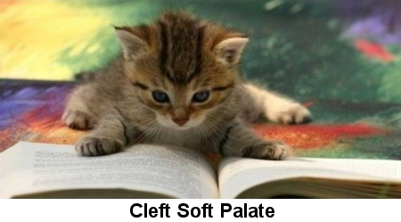

Soft palate disorders are usually congenital defects of the fleshy tissue at the back of the throat that separates the oral and nasal cavities. The most common disorders are a defect or "cleft" in the palate or an elongation of the palate. The soft palate can be traumatized and lacerated, such as following a penetrating stick injury.
Kittens born with palate defects may have problems early on in their development, in the case of clefts. Untreated cleft soft palate can cause difficulty nursing, failure to thrive, pneumonia and death.
What to Watch For
- Kittens that dribble milk from their noses when feeding
- Coughing and gagging
- Thin and poorly nourished pups
- Excitable young brachycephalic dogs with lots of airway noise emanating from the back of their throat, as though they are gagging

Diagnosis
- The diagnosis of a cleft soft palate is usually made from the history; information about the cat's age, sex and breed (signalment); and physical examination. A defect exists between the two sides of the palate leading to a split, which often involves the hard palate, the bony separation between mouth and nose.
- Anesthesia or sedation may be necessary to visualize the tissues in a young squirming kitten.
- The diagnosis of an elongated soft palate is made from the history, signalment and physical examination; thorough visualization of the soft palate almost always requires anesthesia.
- Chest X-rays are useful in newborn kittens to assess for pneumonia, and to assess for concurrent diseases such as a narrowed trachea (tracheal hypoplasia) and heart abnormalities.
- There are no blood abnormalities specific for soft palate disorders.

Treatment
- Young kittens with a diagnosis of cleft soft palate should be tube fed until at least three months of age before undergoing corrective surgery to close the defect.
- Traumatic injuries to the palate should be repaired shortly after the injury, ensuring that any perforating material is not left behind in the throat or neck to cause future problems.

Home Care
- Whatever the nature of the surgery on your pet's soft palate, your animal will have been closely monitored for respiratory difficulty in the immediate postoperative period. Your pet will probably stay at your veterinary hospital for a day or two after the procedure.
- Once at home your cat should be kept quiet and rested, avoiding excitement and should be watched closely when eating or drinking. Small, easily digested food should be offered initially.
- All sutures used at the time of surgery will be absorbable, so suture removal will not be necessary. Your veterinarian may suggest you return some two weeks after the procedure for a check-up.

Preventative Care
- Since cleft soft palate is a congenital problem, it is usually detected by breeders, and the sire and dam should be avoided in a breeding program.

