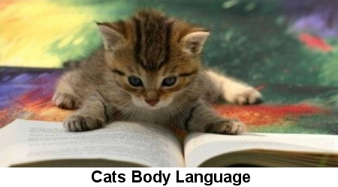
by Colleen Dougherty
Provided by CatTime

Cats are savvy communicators, using nearly every part of their bodies to “talk.” Being savvy yourself in interpreting their language can help you bond with your cat, alleviate frustrations, and even prevent accidents.



Affection: Did you know if your kitty “head-butts” or licks you, it means she really likes you? Rubbing on nearby objects is called “redirected affection.” If her tail pops straight up as she’s walking toward you, she’s happy to see you. If she’s grooming in short, rapid strokes, and looking at you, she’s saying, “all is well.” Bright eyes, perked up ears, and forward-facing whiskers mean she’s ready for some interaction.

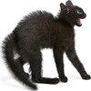

Aggression: Aggression can be defensive or offensive. A defensive cat is fearful, and reacting to a threat. She might be curled up in a ball, rolled to one side, tail tucked in close. Her ears will be flattened, pupils dilated, and she may be hissing. If the threat continues, she may launch an attack. If you see your cat in this position, don’t approach; stay several feet away and speak softly until she calms down – and let her come to you for reassurance afterward. Offensive aggression is the “Halloween Cat” – hair standing up, back and tail arched, pupils huge, tongue curled, hissing or yowling... a cat in this pose is ready to (but may or may not) attack. Nevertheless, get out of the way.

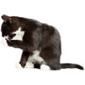

Boredom: If your kitty is bored, she may groom constantly, with long, intense strokes. Her tail might be low, at “half-mast,” or swishing slowly back and forth, telling you, “I’m not happy.” She may pace back and forth, sigh, or talk to you as if to say, “I need something to do.”



Illness: A crouched body and tucked tail may mean your kitty is in pain or ill. Look for half-closed eyes, downcast ears, or a blank expression. Obviously a kitty lying on her side but unresponsive or breathing funny needs immediate medical attention.

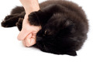

Overstimulation: Many owners end up bewildered (and bleeding) by a “sudden” attack during a play, petting, or brushing session. Overstimulated cats sometimes respond with a burst of energy directed at the nearest object – maybe you. But there are warning signs: Her tail will begin to swish back and forth, ears will twitch forward and back, she may vocalize, or turn her head toward your hand. When you see these signs, stop the activity and give her a time-out until her adrenaline calms down. She may still strike out, however, so be prepared.



Relaxation: Cat owners have all seen (and envied) the postures of a relaxed cat. They just seem to melt into whatever surface they’re on. They roll onto their backs, or pose like a “J” with their head sideways and upturned, the rest of their body lengthened and still. Eyes can convey relaxation too, in slow blinks, normal-sized pupils, and soft gazes.

Learning to interpret and respond to cat-talk can truly enhance your relationship with your feline. She’ll teach you – so be ready to learn.

